“The Last-Minute Review of Essentials”
===================================================================================
NIST SP 800-145 Cloud Definition
“Cloud computing is a model for enabling ubiquitous, convenient, on-demand network access to a shared pool of configurable computing resources (networks, servers, storage, applications, and services) that can be rapidly provisioned and released with minimal management effort or service provider interaction.”

5 NIST Essential Characteristics
On-Demand Self-Service – Provision resources without provider interaction
Broad Network Access – Access via standard networks with various device types
Resource Pooling – CSPs group resources to serve multiple customers dynamically
Rapid Elasticity – Scale up/down dynamically to meet rapid changes in demand
Measured Service – Measured / Metered usage for billing/monitoring.
Cloud Service Models
IaaS – Provider delivers compute, storage, and networking; customer manages OS and above.
PaaS – Provider delivers runtime, middleware, and infrastructure; customer develops/deploys apps.
SaaS – Provider delivers fully managed apps over the internet; customers only use the software.
Cloud Deployment Models
Public Cloud  Pros: Scalability, cost efficiency.  Cons: Multi-tenancy risk, less control  Security: Strong tenant isolation needed.  Use Case: Web hosting, SaaS apps. | Community Cloud  Pros: Cost split, shared compliance.  Cons: Governance complexity.  Security: Joint security policies.  Use Case: Gov/healthcare consortiums.
Private Cloud  Pros: More control, custom security.  Cons: Higher cost, less elasticity.  Security: Org controls all layers.  Use Case: Regulated workloads. | Hybrid Cloud  Pros: Flexibility, workload portability.  Cons: Complex integration.  Security: Consistent policy enforcement.  Use Case: Bursting from private to public.
Cloud Foundation Components
Compute – Processing power for workloads.
Virtualization – Abstracts hardware for multiple OS instances.
Storage – Persistent or ephemeral data holding.
Networking – Connectivity between resources and the internet.
Orchestration – Automated management of resources/services.
Cloud Core Roles (From the CSA)
Customer – Uses cloud services; defines requirements; ensures internal compliance.
Provider – Delivers cloud service; enforces SLA terms; maintains infrastructure.
Partner – Integrates, customizes, or supports cloud services for the customer.
Broker – Manages service selection, aggregation, and integration.
Regulator – Sets/enforces compliance rules; audits adherence.

“The Last-Minute Review of Essentials”
===================================================================================
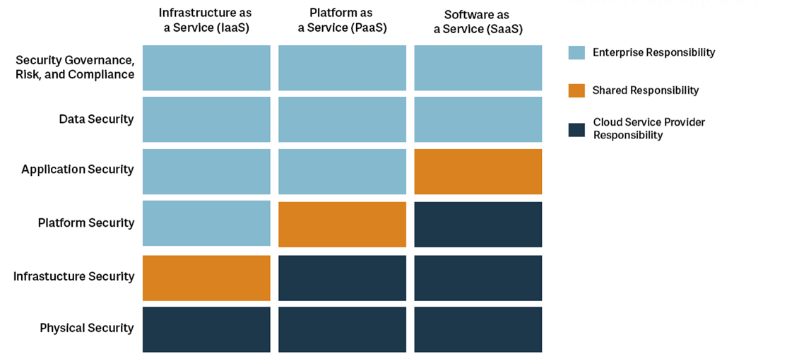
Official ISC2 Shared Responsibility Model
Note: Models differ slightly, below is a consolidated perspective of the Concept from multiple sources
Think of it as:
- IaaS → You manage most; provider handles hardware & virtualization.
- PaaS → You manage apps & data; provider handles OS down.
- SaaS → You manage data & access; the provider handles almost everything else.
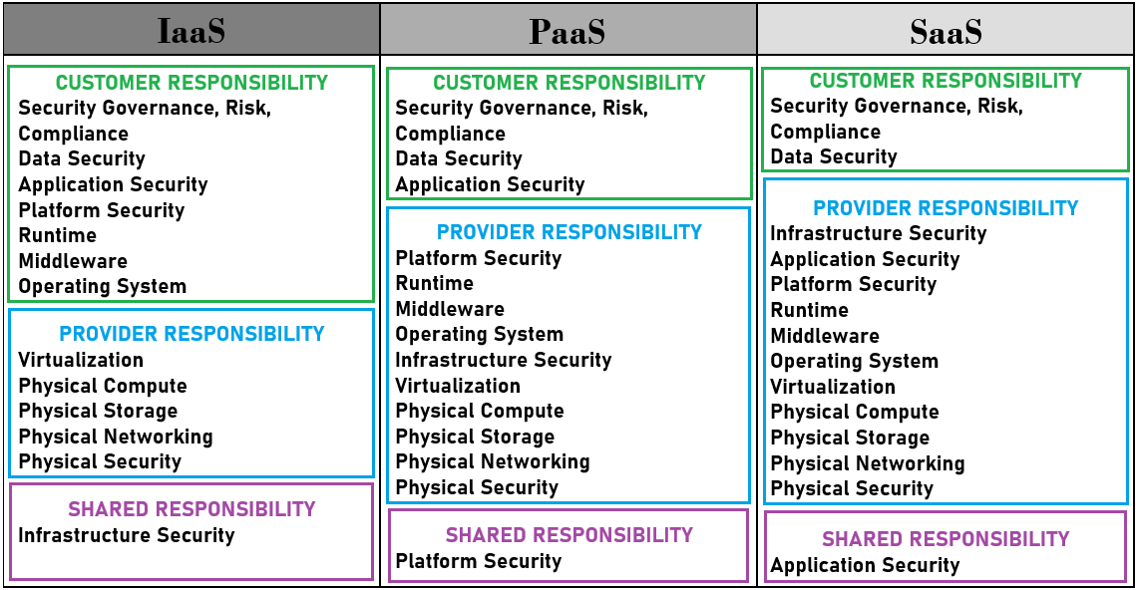
Shared Responsibility Concept Consolidated
“The Last-Minute Review of Essentials”
===================================================================================

Additional Shared Responsibility Models to Reference
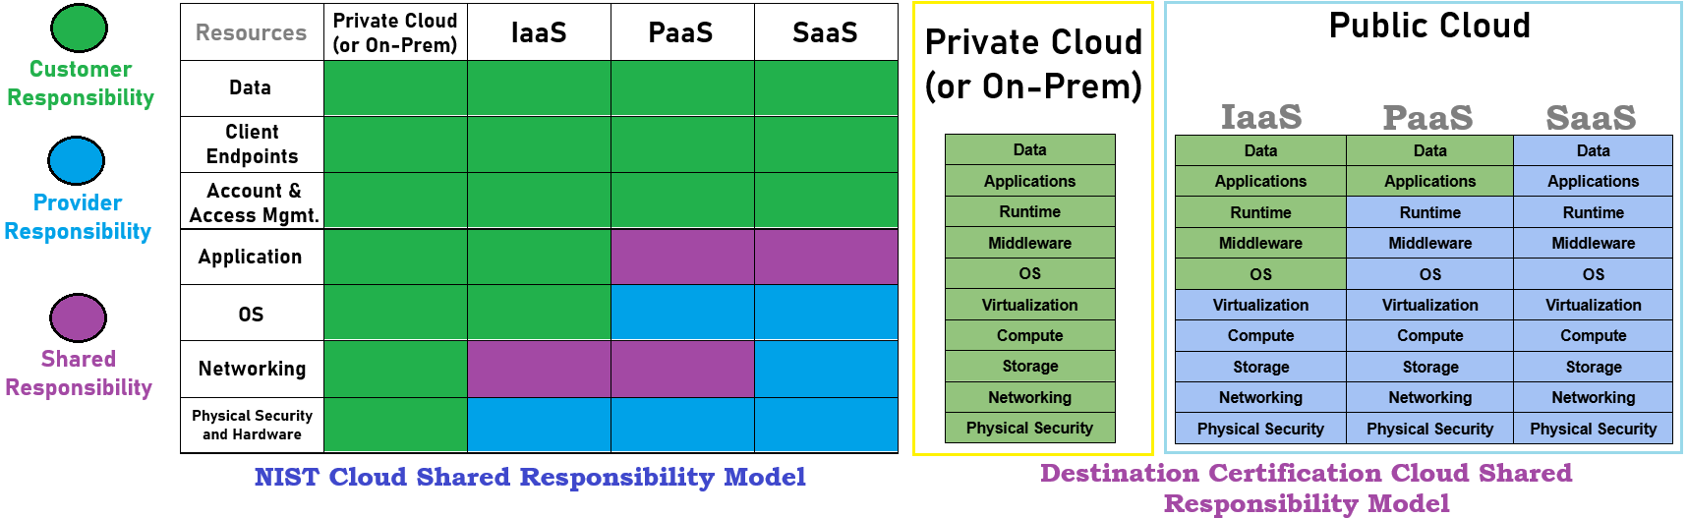
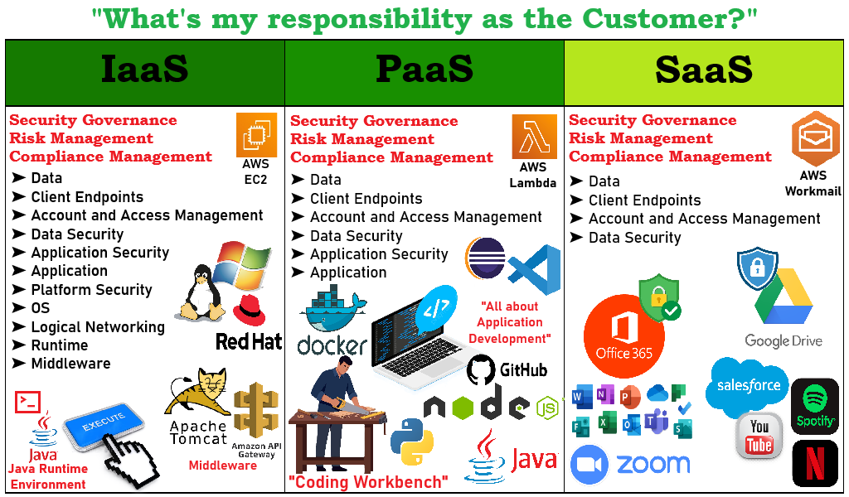
Stupid Easy Way to Remember the 3:
✪ IaaS = “The on-demand, virtual hardware marketplace of the cloud”
✪ PaaS = “The application development workbench”
✪ SaaS = “The fully furnished apartment of the cloud - ready to go with subscription!”

